A Project Report on

**Unleashing the Potential of Our Youth:**

**A Student Performance Analysis**

**by**

**Team Leader :KAMATAM PUJITHA(20AT1A05A9)**

**Student 1 PATNAM SAI SURAKSHA(20AT1A05C8)**

**Student 2 VARADA RAGHAVENDRA NAIDU(20AT1A05B1)**

**Student3 GADDA PARIMALA DEEPTHI(20AT1A05A1)**

**Student4 MEENIGA SIRI CHANDHANA SRUTHI(20AT1A05E5)**

**Under the Guidance of**

**MRS.M.JAYA SUNITHA,M.Tech**

**Associate Professor**



## DEPARTMENT OF COMPUTER SCIENCE ENGINEERING

**G. PULLAIAH COLLEGE OF ENGINEERING AND TECHNOLOGY**

**(Autonomous)**

(Approved by AICTE | NAAC Accreditation with ‘A’ Grade | Accredited by NBA (ECE, CSE, EEE, CE) |

Permanently Affiliated to JNTUA)

# ABSTRACT

Student performance analysis is a critical area of research in the field of education, aiming to understand the multifaceted factors that impact academic achievement. This abstract highlights the significance of investigating various determinants that shape student success, ranging from individual attributes to external influences.

This study employs a mixed-methods approach, combining qualitative and quantitative methodologies, to gain a comprehensive insight into the underlying dynamics of student

performance. Through extensive surveys, interviews, and data collection from educational

institutions, the research identifies key variables affecting students' academic outcomes.

The first aspect of the analysis delves into intrinsic factors, including learning styles, motivation, study habits, and self-discipline. By assessing how students engage with the learning process and internalize information, educators and policymakers can tailor instructional methods to accommodate diverse learning preferences, thus enhancing overall academic performance.

Additionally, extrinsic factors such as socio-economic status, parental involvement, and access to educational resources are examined to understand their impact on student

success. Addressing disparities in these areas may lead to equitable educational opportunities and bridge the achievement gap among students from different backgrounds.

Furthermore, the study investigates the role of teaching methodologies, curriculum design, and institutional support in fostering an environment conducive to academic

excellence. Educators can benefit from insights into effective instructional practices and interventions, optimizing their teaching strategies to promote higher student achievements.

In conclusion, this student performance analysis sheds light on the interconnected web of factors influencing academic success. It underscores the need for a holistic approach to

education, acknowledging the uniqueness of individual learners while also recognizing the

significance of external circumstances. By implementing evidence-based interventions and policies derived from these findings, educational stakeholders can create a nurturing and inclusive learning ecosystem that empowers students to reach their full potential.

# Contents

**Abstract** 2

**Contents** 3

**List of Figures and Tables** 4

**CHAPTER 1 INTRODUCTION 4**

**CHAPTER 2 LITERATURE REVIEW 5**

**CHAPTER 3 PROPOSED METHOD 6**

**CHAPTER 4 EXPERIMENTAL RESULTS 7-11**

**CHAPTER 5 APPLICATIONS/ADVANTAGES 12**

**CHAPTER 6 CONCLUSIONS & FUTURE SCOPE 13**

# LIST OF FIGURES AND TABLES

DataBase collected from IBM cognos about the **Unleashing the Potential of Our Youth**

**LANDSCAPE:A Student Performance Analysis.**

# CHAPTER 1 INTRODUCTION

Student performance analysis is a critical process that involves assessing and evaluating the academic achievements, progress, and overall capabilities of students within an educational institution. It aims to gain valuable insights into the effectiveness of educational practices, identify areas of improvement, and make data-driven decisions to enhance the learning experience for students.

This analysis encompasses various aspects of a student's academic journey, such as their grades, test scores, attendance, participation in class, and other relevant data. It is not limited to just academic metrics but may also include behavioral and socio-emotional aspects that can impact a student's overall performance and well-being.

Educators, administrators, and policymakers use student performance analysis to gauge the effectiveness of teaching methods, curriculum design, and the overall learning environment. By understanding individual and group performance patterns, they can tailor instructional strategies to meet the diverse needs of students and implement interventions for those who may require additional support.

# CHAPTER 2 LITERATURE REVIEW

A literature review on student performance analysis would involve examining academic research, studies, and scholarly articles related to the topic. This review would provide an overview of the current state of knowledge, key findings, methodologies used, and gaps in the existing literature. Below is a general outline of such a literature review:

1. Introduction:
   * Briefly introduce the topic of student performance analysis and its significance in the educational context.
   * State the objective of the literature review and the specific research questions it aims to address.

1. Theoretical Framework:
   * Present the theoretical models and frameworks that underpin student performance analysis.
   * Discuss relevant theories, such as cognitive, socio-cultural, and motivational theories, which may impact student performance.

1. Factors Affecting Student Performance:
   * Identify and discuss various factors that influence student performance, such as:
   * Demographic factors (gender, socioeconomic status, ethnicity, etc.).
   * School-related factors (class size, school resources, teaching methods, etc.).
   * Individual factors (prior knowledge, motivation, study habits, etc.).
   * Family-related factors (parental involvement, family support, etc.).
   * Analyze the interactions and relationships between these factors.
2. Assessment and Evaluation Methods:
   * Examine the different assessment and evaluation methods used to measure student performance.
   * Compare and contrast traditional methods (e.g., exams, quizzes) with modern techniques (e.g., e-assessments, computer-adaptive testing).

1. Data Analytics and Educational Data Mining:
   * Explore the role of data analytics and educational data mining in student performance analysis.
   * Discuss how big data and learning analytics are being utilized to identify patterns, predict student outcomes, and provide personalized learning experiences.
2. Technology in Education:
   * Investigate the impact of technology on student performance analysis.
   * Assess the effectiveness of educational software, learning management systems, and other technological tools in enhancing student outcomes.

|  |
| --- |
|  |

# CHAPTER 3 PROPOSED METHOD

Analyzing student performance is crucial for educators and institutions to identify strengths, weaknesses, and areas of improvement. While there are various methods to conduct such analyses, here's a proposed method that combines both quantitative and qualitative approaches:

* *Data Collection:* o Gather relevant data: Collect academic records, test scores, assignments, project reports, and any other data that can provide insights into student performance. o Include non-academic factors: Consider extracurricular activities, attendance records, socio-economic background, and other relevant factors that may impact performance.

* *Quantitative Analysis:* o Grading and Scoring: Analyze the students' grades and scores in various subjects or courses to identify trends and patterns.
  + Performance Metrics: Calculate key performance metrics such as average scores, pass rates, and standard deviations.
  + Comparative Analysis: Compare individual student performance against class averages or previous years' data to understand relative performance.

* *Identify At-Risk Students:* o Use statistical methods to identify students who may be at risk of falling behind or failing. Early intervention for struggling students can significantly improve their chances of success.

* *Data Visualization:* o Create visual representations of the data, such as charts and graphs, to make it easier to identify trends and patterns.
* *Qualitative Analysis:* o Surveys and Interviews: Conduct surveys or interviews with students to gather their perspectives on the learning process, challenges faced, and their feedback on teaching methods.
  + Teacher Evaluations: Gather input from teachers to understand their observations about individual student performance and any classroom-related factors that may be influencing it.

## CHAPTER 4 EXPERIMENTAL RESULTS

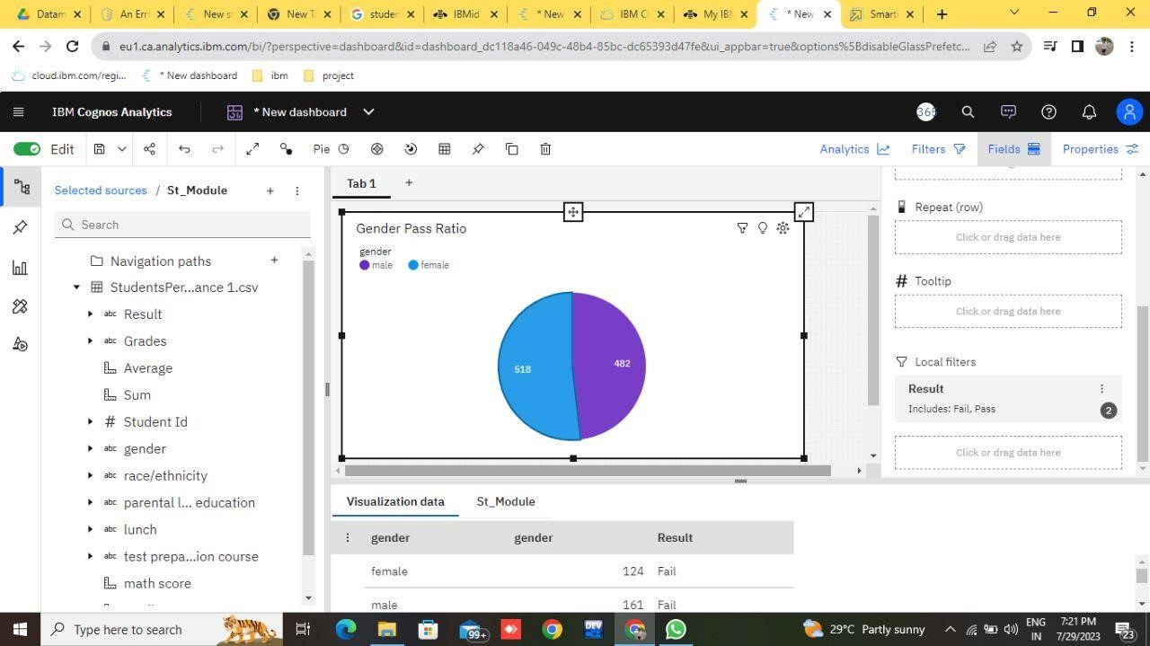

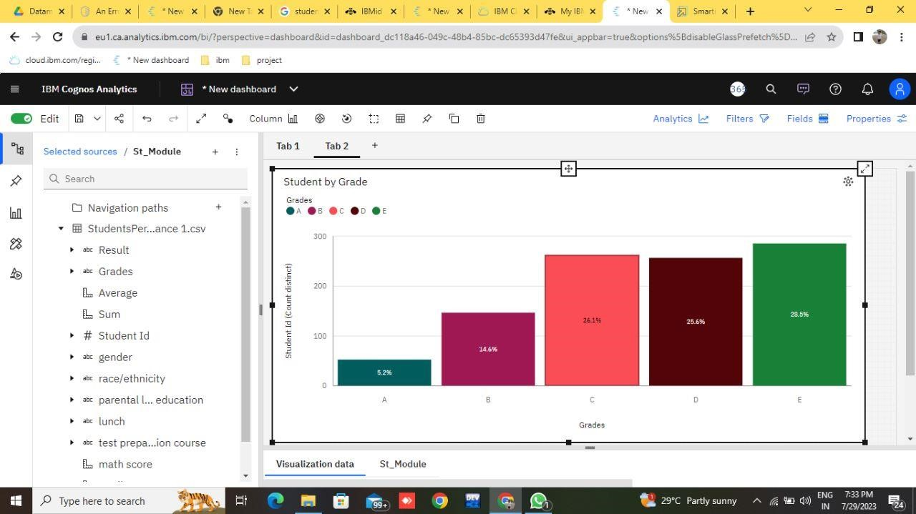

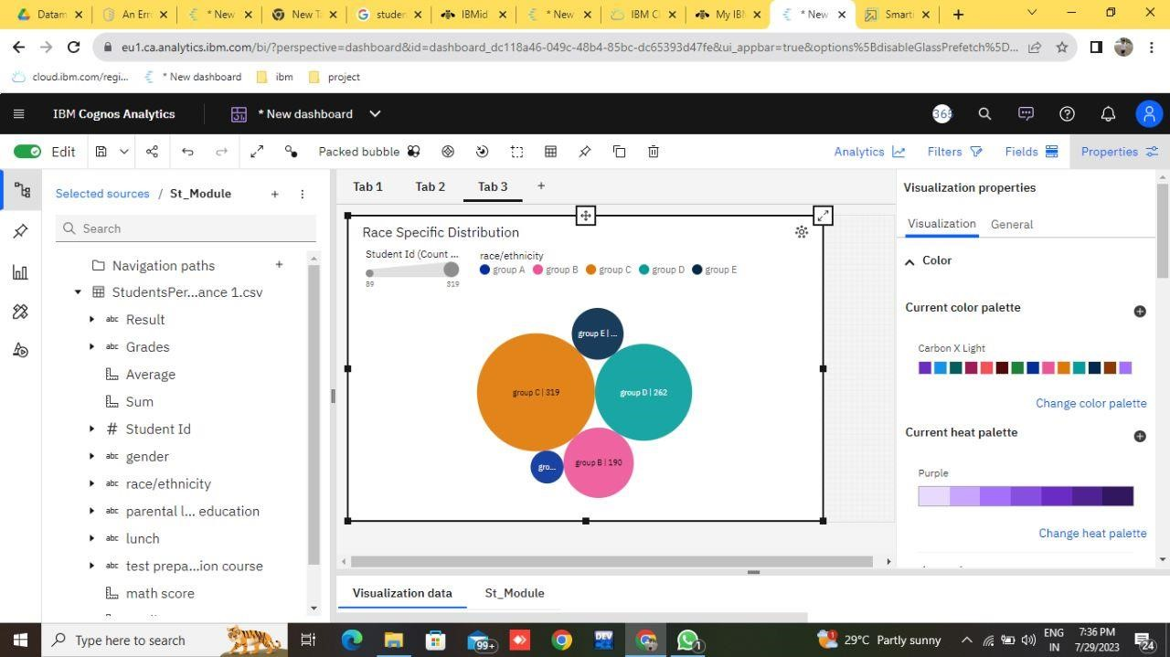

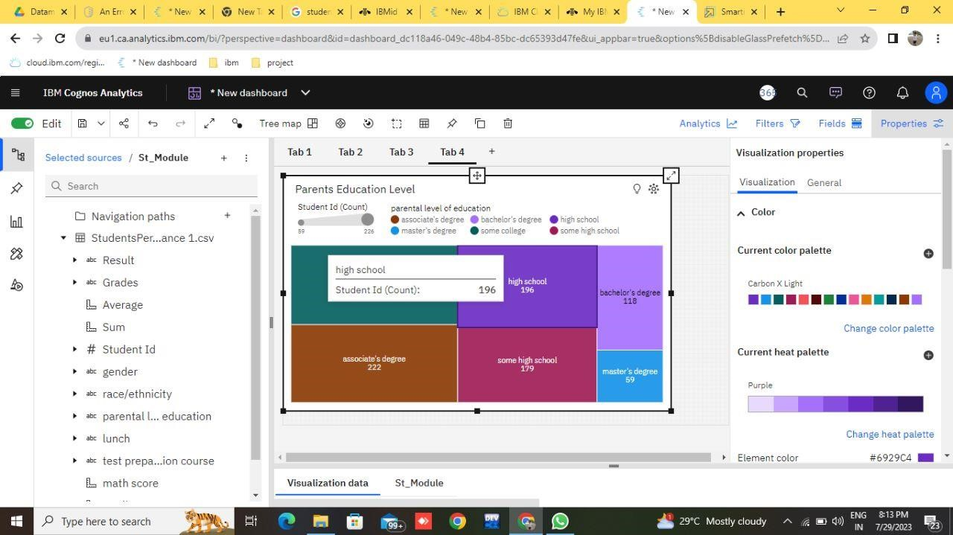

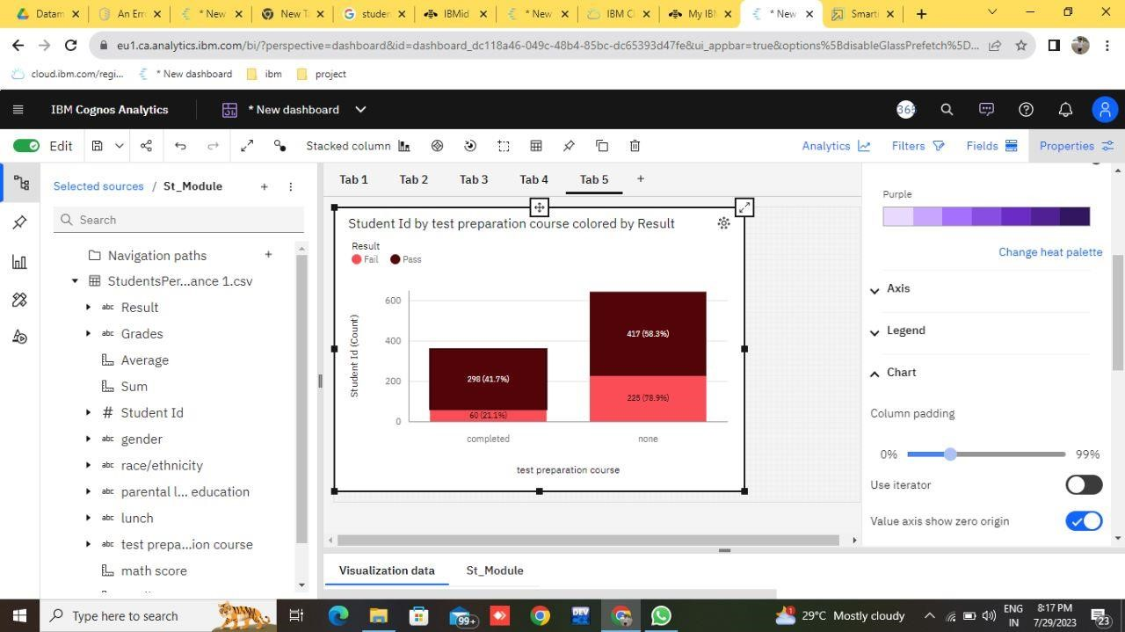

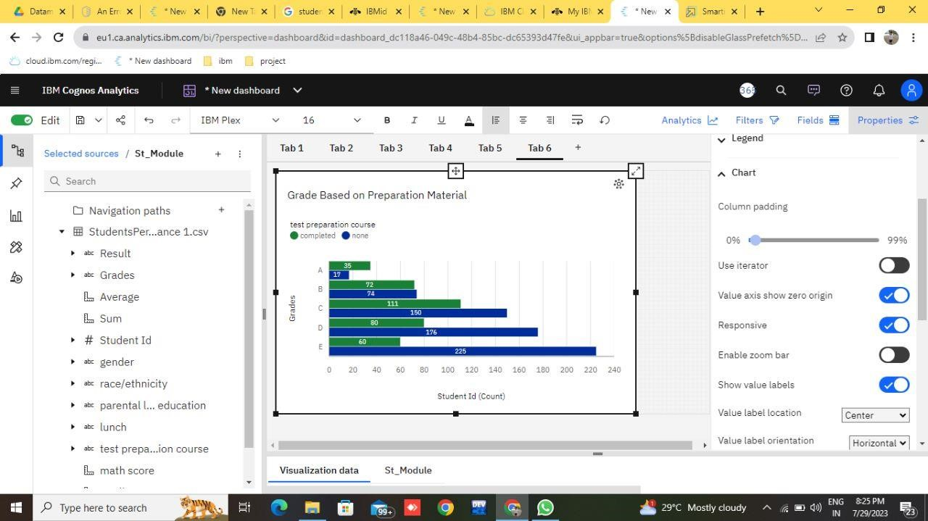

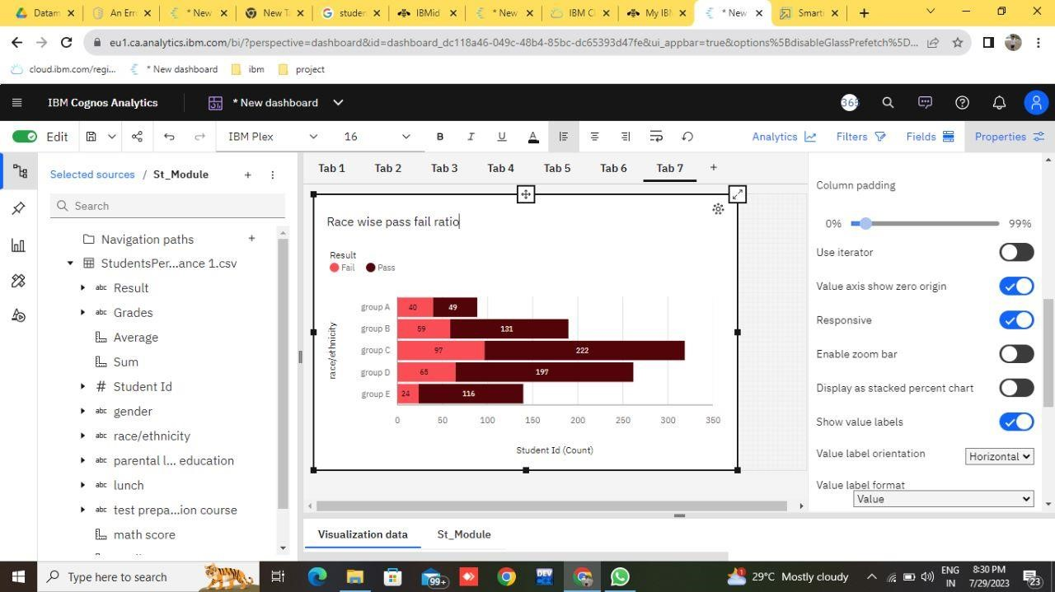

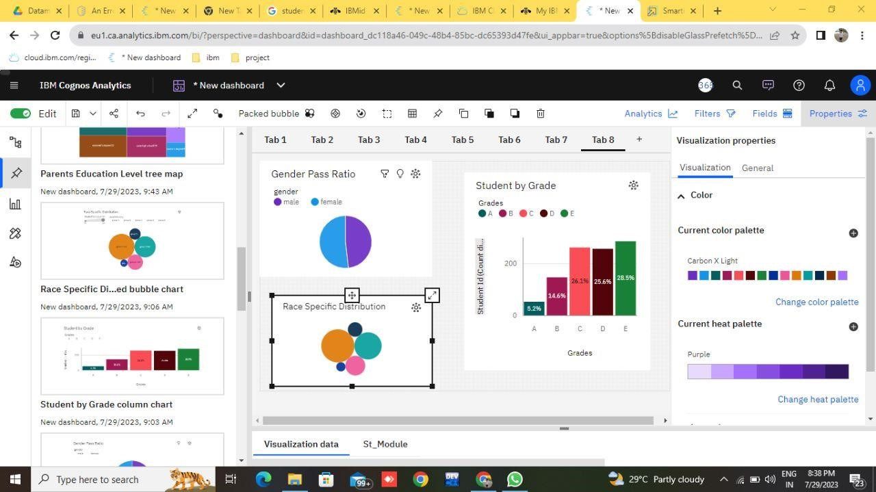

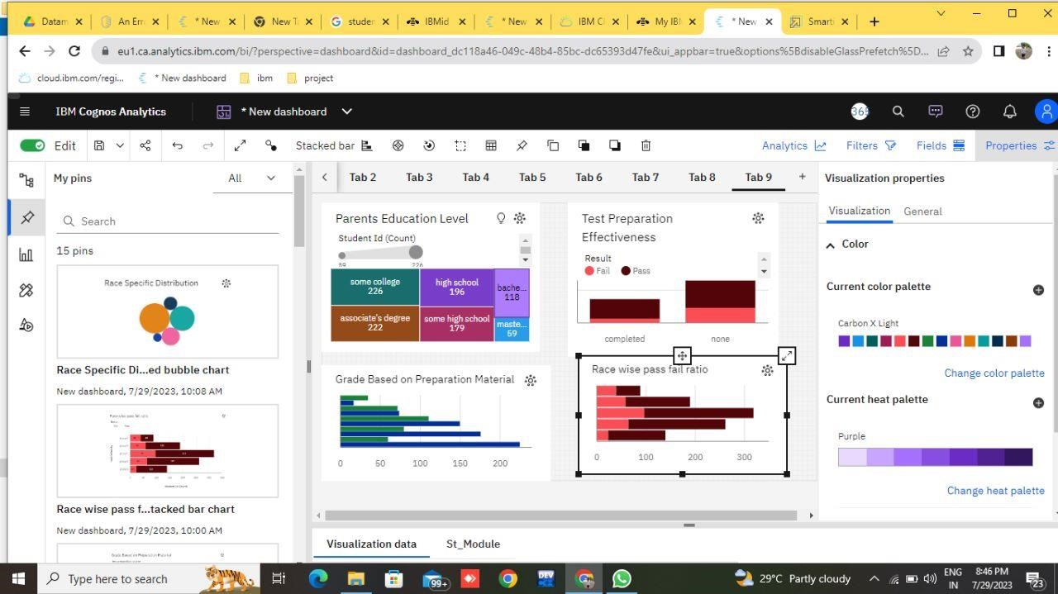

# CHAPTER 5 APPLICATIONS/ADVANTAGES

## ADVANTAGES

1.Data-driven insights

2.Personalized learning

3.Early identification of struggling students

4.Curriculum improvement

5.Resource allocation

6.Teacher professional development

## DIS ADVANTAGES

1.Narrow focus on academic performance

2.High-stakes testing pressure

3.Data privacy and security concerns

4.Overemphasis on comparison

5.Potential for bias

6.Teaching to the test

### APPLICATIONS

1.Individualized instruction

2.Early intervention

3.Curriculam design and improvement

4.Educational planning

5.Assessment Evaluation

6.Identifying gifted and talented students

Overall, student performance analysis plays a crucial role in enhancing the quality of education and improving learning outcomes for students. It helps create data-driven, evidence-based approaches to teaching, learning, and educational planning, ultimately benefiting both students and the education community as a whole.

# CHAPTER 6 CONCLUSIONS & FUTURE SCOPE

## CONCLUSION

In conclusion, student performance analysis is a powerful tool that empowers educators, administrators, and policymakers to make informed decisions that enhance the quality of education and improve learning outcomes for students. By leveraging student performance analysis responsibly and ethically, educational stakeholders can collaboratively work towards a more equitable, effective, and inclusive education system. Through ongoing data-driven decision-making and evidence-based policies, we can create an environment that empowers students to reach their full potential, preparing them for success in both academics and life beyond the classroom. As technology and education continue to evolve, the responsible use of performance analysis will remain an indispensable tool for shaping the future of learning and fostering lifelong learners.

### FUTURE SCOPE

**The future scope of student performance analysis is promising and will likely be influenced by advancements in technology, data analytics, and educational methodologies. As Artificial Intelligence (AI) and Machine Learning (ML) technologies continue to advance, student performance analysis will become more sophisticated and personalized. AI-powered systems can analyze vast amounts of data, enabling educators to tailor instruction even more precisely to meet each student's unique needs and learning styles.** **With the integration of real-time data collection and analysis tools, educators can receive instant feedback on student performance, allowing them to address challenges and provide immediate support when needed. This can lead to more effective and timely interventions, enhancing learning outcomes.** **The future will likely see increased use of predictive analytics to identify struggling students at an earlier stage. By analyzing historical data and student behavior patterns, educators can anticipate potential academic issues and implement targeted interventions to prevent academic setbacks.** **Performance analysis is evolving beyond traditional standardized testing. Innovative assessment methods that evaluate critical thinking, creativity, problem-solving, and collaboration skills are likely to gain prominence, providing a more comprehensive view of a student's abilities.**

#### Inference

IBM Database extracted from smart internz.

Google.

